Nuno Miguel Pinto Lopes Dinis Santos

**Full product**

apps+game

**Dissertação no âmbito do Mestrado em Engenharia Eletrotécnica e de Computadores orientada pelo Professor Paulo Jorge Carvalho Menezes e apresentada ao Departamento de Engenharia Eletrotécnica e de Computadores da Faculdade de Ciências e Tecnologia da Universidade de Coimbra**

Fevereiro de 2025

Page intentionally left blank.

Acknowledgements

I would like to thank my teacher Professor Paulo Menezes who gave me this challenge and accepted being my mentor in this project.

A big thank you to my work colleague Tiago Santos, who ensured I was following good programming practices.

**Abstract**

Abstract here…

Page intentionally left blank.

**Motivation**

This dissertation started with one motivation, which is clear in the objective itself it wants to achieve. We have known for some time that people lifestyle is becoming more sedentary which is leading to an overweight population. An overweight populate brings more risks and more expenses in health. Having this analysis, we hope to target this sedentarism by motivating people to exercise while having fun.

However, there have already been many studies and prototypes coming from this university and students somehow are not familiar with real world techniques and technology to make a complete product. So, I took the liberty of gathering, learning, develop and creating several steps so students, like me, who want to take their projects to the next level, can have several tips and good practices to elevate their work.

**Objectives and contributions**

This work is target mainly at students or any younger audience who enjoys playing games. The objective is to force players to exercise while having fun, forgetting the burden of working out. However, being the target a younger audience, we face more challenges on player retainability and acceptance. So the game Mistérios Aquáticos was developed to be fun enough so players keep playing the game for a period of time. However, more variables were used to have more retainability, we believe that offering real world rewards to players was also a motivation for them to keep playing, hence, keep exercising.

**Context**

Being this project a full ecosystem, we need to understand what is being made and how everything is connected. We have five major parts for this dissertation which we will carefully study.

- Game Mistérios Aquáticos

- Website misteriosaquaticos.pt

- API

- Proxy program

- Super user APP

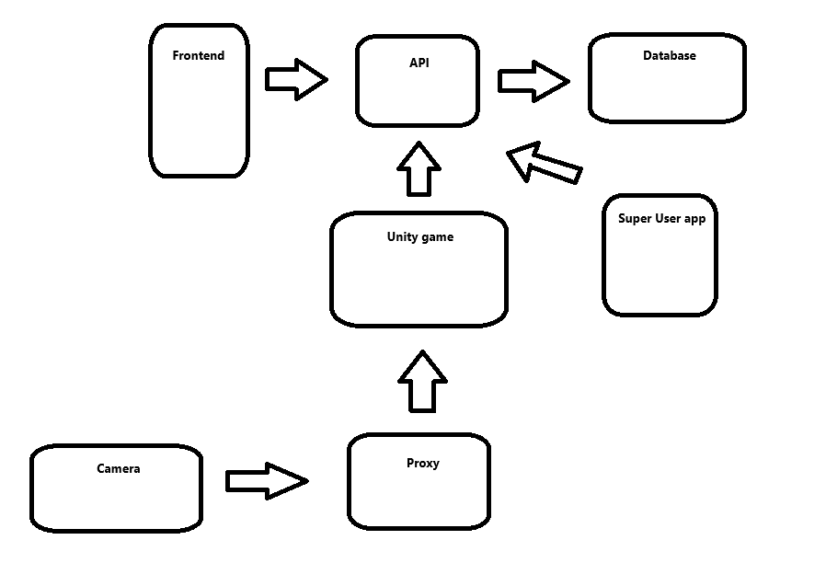

**Game**

**-**Mistérios Aquáticos Overview

The game is placed in a small island where a team of scientists are there to study some lost treasures and places under the sea. It is up to the player, with his trustworthy seamoth built and maintained by DEEC engineers, to discover these mysteries. The game is composed by several zones which have their own fauna, making the game much more interesting. There are no dangers in the game, however, the seamoth can be broken if the player tries to go to certain zones which is not prepared to. This means that the player must upgrade his seamoth to go to certain places, making the game much more interesting and having a sense of progression. The upgrade is made using coins, which can be traded for fish that the player catches every day. With these coins the player can buy several modules which will allow him to explore new zones and be able to catch new types of fish.

Upon starting the game, the player sees a menu where it can insert his ID (should be his student number). When clicking the Começar! Button, meaning Start! In Portuguese, the game tries to load the players data into the game. This load is an API call, which calls a GET endpoint and returns the correct data. If no player is found with the ID chosen, the game will throw a controlled error.

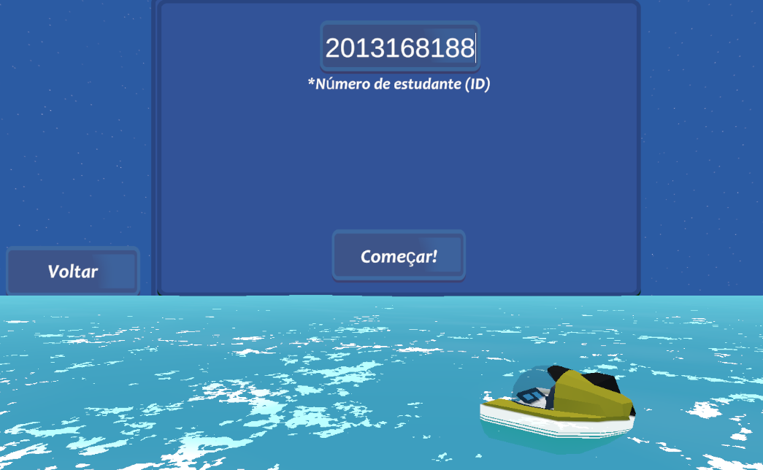

If the load is successful, the data will be stored in the PlayerDataInstance.

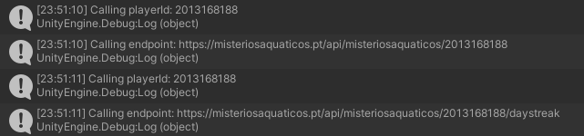

-API connection

This game is prepared for many players to play it. Meaning that we must be able to have each player progress saved, as well as load their progress so they can continue playing. This is where the API connection comes in. Unity has a set of methods which allow us to call an API endpoint to tackle this problem. We will cover the API itself in a later section, however, for Unity, we only need to know which endpoint to call.

-Design choices

The design was chosen to be as chill as possible, so we have a sense of security in the game. It was also chosen a low poly asset bundle due to have lower impact on performance.

-Optimization techniques

Optimization is an important part of every game. It is a good practice to have the game as optimized as possible, so it runs on lower end devices and runs at a stable FPS count.

There are many techniques in which a game can be optimized, from careful programming, using clever tactics and understanding the Unity Profiler. For this game, several optimization techniques were used that every game should consider.

-Unity Profiler

One of the first concerns we must have is knowing where our game suffering the most. In CPU or GPU. CPU has to do with scripts and animations, while GPU has to do with everything which is being drawn. PlayerLoops (Update methods), Coroutines, animations, shadows, physics are all heavy on the CPU, while every mesh that is being drawn is on the GPU. This means that more detailed models will be heavier on the GPU performance.

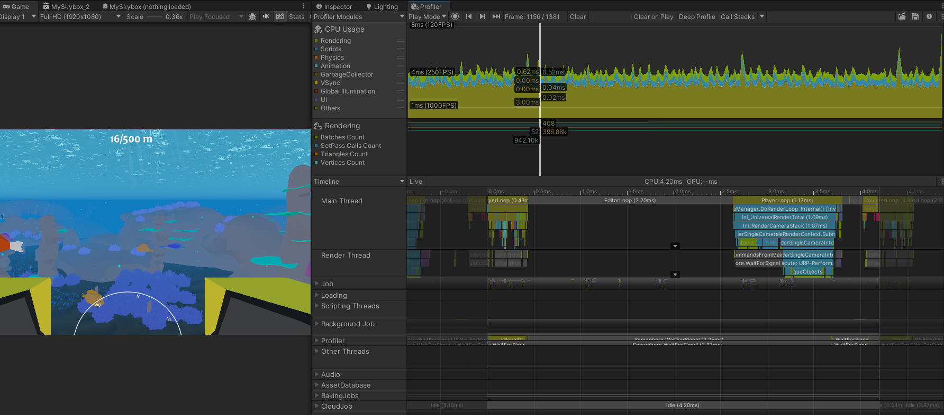

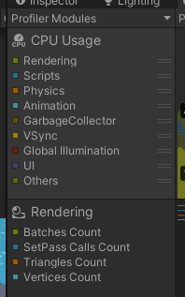

For CPU we could find a spike and analyse it carefully

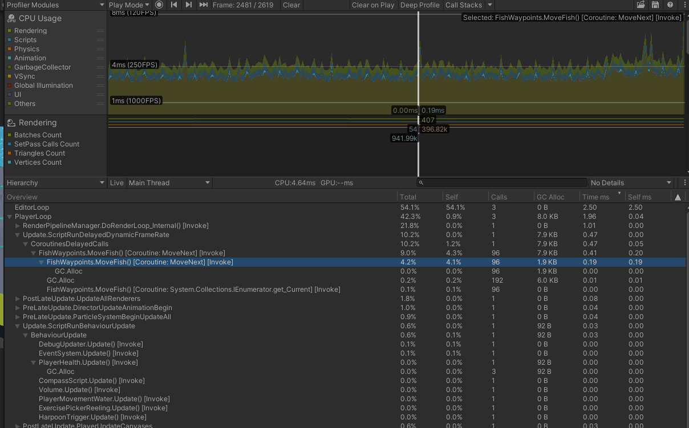

First let’s ignore the Editor loop. This is simply because we are in the Unity Editor, so it won’t affect our game once we build it. However, if we look at the PlayerLoop, we can see that the FishWaypoints and PlayerHealth are taking up memory and are responsible for most of the calls being made.

For Rendering (GPU) there are good measure values which we should follow. These are the Set pass calls.

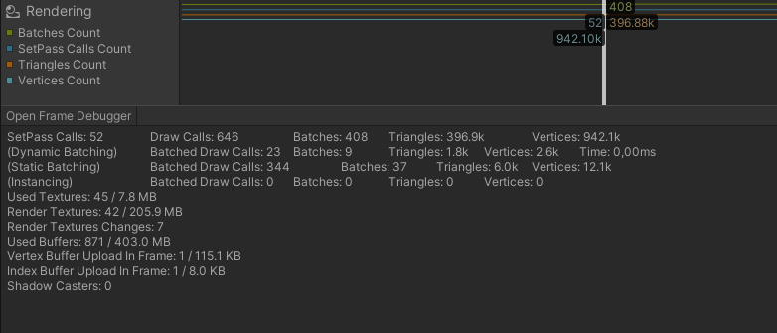

If we open the Frame Debugger, we see how Unity is drawing the scene.

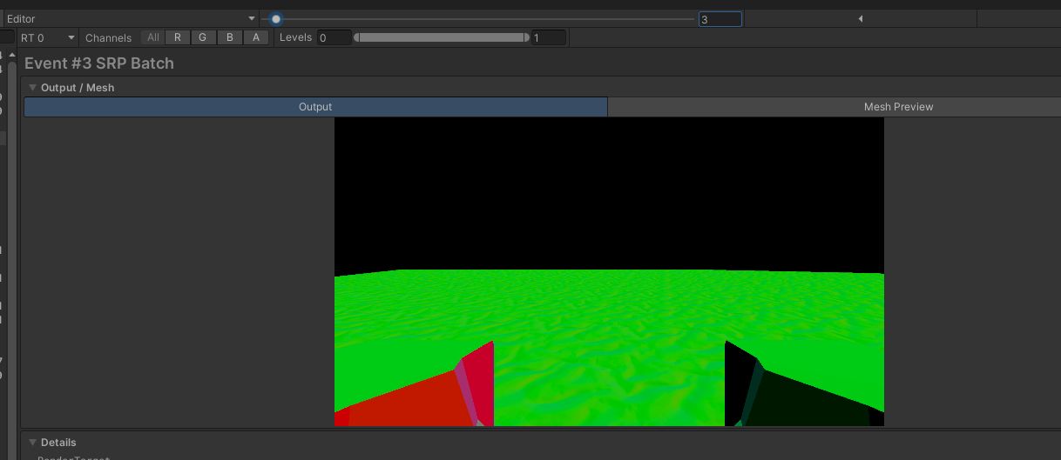

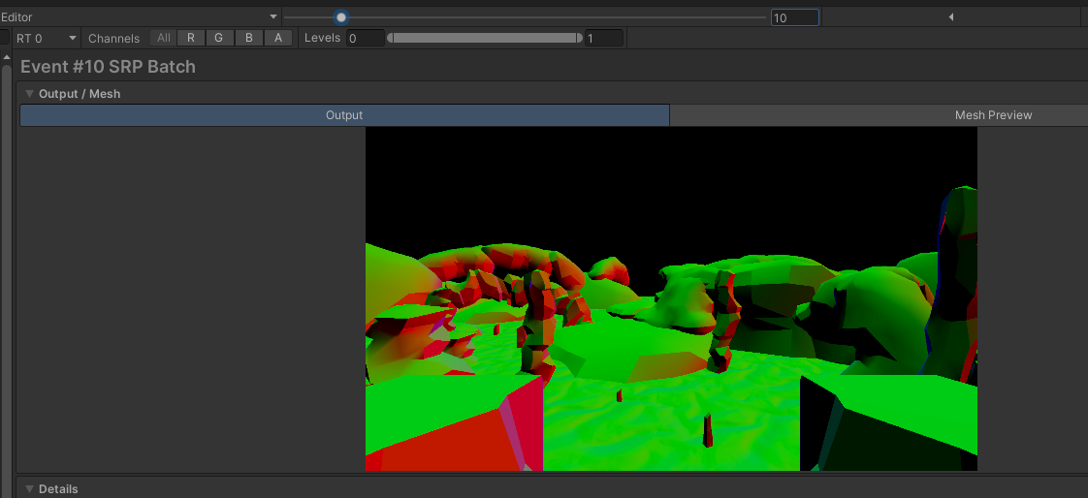

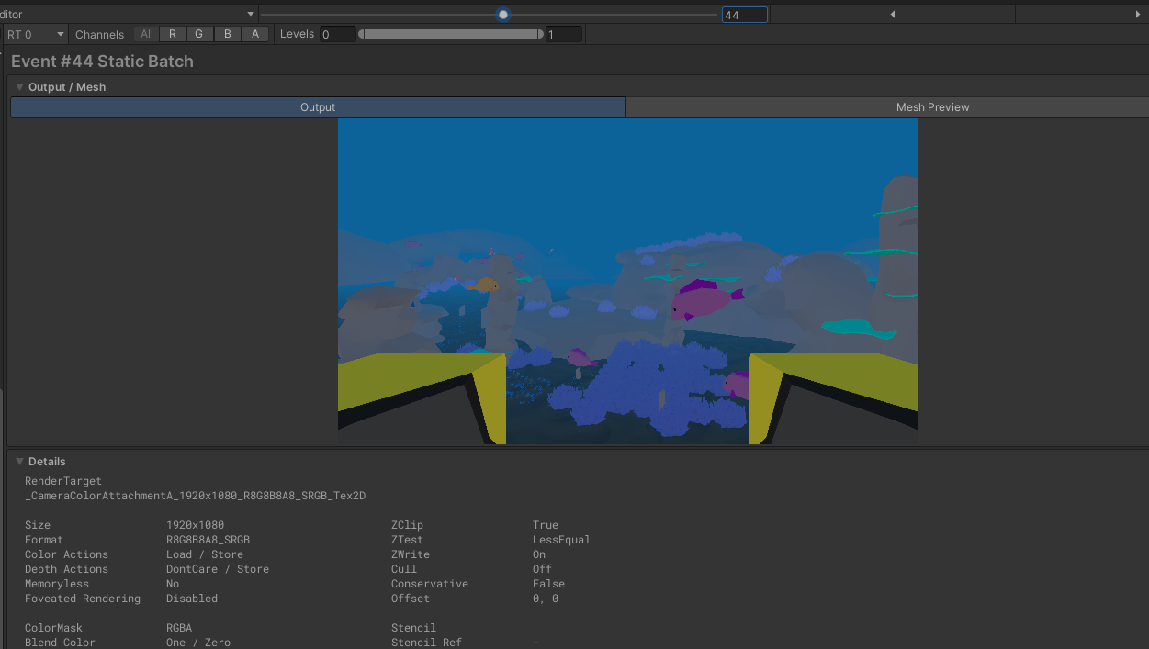

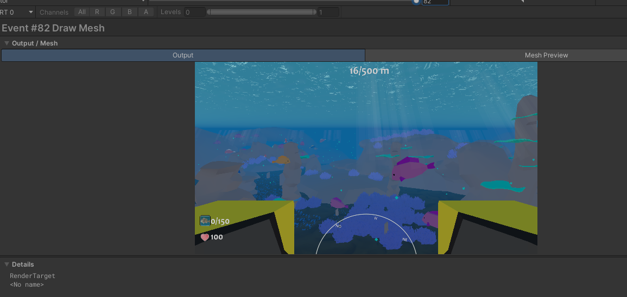

Notice how the event ends at 82 which is the sum of both UniversalRenderPipeline.RenderSingleCameraInternal:Main Camera and UGUI.Rendering.RenderOverlays.

The URP is responsible for what the main camera is seeing, while the UGUI is usually what is in the Canvas.

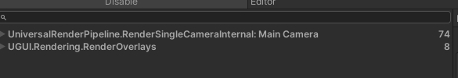

-Combining mesh

Static objects can be combined if they have the same materials. Using this technique can massively decrease the number of draw calls.

-Baking lights

Baking lights in the scene create a lightmap. This lightmap is then applied to the mesh with the correct lighting. This of course means that new lights won’t affect the mesh but we are able to combine it.

-Object pooling: In this game we have a lot of fish that need to be spawn. Since we can catch the fish, we would need to make them disappear. The first thought is to use a method that Unity offers, Destroy(), however, this method is very intensive on performance. To make matters worse, when we use Destroy(), if we want to new fish to spawn, we need to use the Instantiate() method, which is even worse. Therefore, we use object pooling. By using this technique, we only instantiate each fish one time, and every time we need to make them disappear, we deactivate it instead of destroying. Deactivating is much less costly and reduces the draw calls, meaning that the performance impact is close to zero.

-Vertex shaders: Animating one fish with bones would probably look nicer, however, one fish would need several bones. These bones would need to be updated in the CPU (which is where the animation takes place). Multiply that by hundreds of fish and it would drop the FPS count considerably, to a point it would be unplayable.

This is where vertex shader shine. We take advantage of the power of the GPU to draw the object with a sin wave applied to the vertices we want to move. This technique is very used in movement of leaves, grass and now, fish.

-Fog: Unity camera has an option for drawing distance which drastically reduces performance if the value is big. This is because we are spending resources drawing things that the player would not even need to see. Therefore, we reduce this drawing value and apply fog, so the image does not end abruptly.

-Render distance (LOD – Level Of Detail): This technique is used when we need to populate the scene at higher distances, but we do not need the full detail of the objects being drawn. If, however, the player starts approaching these objects, they are switched with a higher polygon version so all details are there.

-Limited Drawing: As mentioned previously, deactivating objects can greatly reduce the impact on performance, so the game deactivates everything underwater when the player is on shore, so he can look as further as possible and not impacting performance.

-Shaders

Shaders are often confused with materials. Shaders are how the GPU projects what we see on our screens and can hold several values, like colour, texture, noise, floats, etc. Materials use that shader, each with their own values of colour, texture, noise, etc, and are applied to objects. Meaning that three objects can have three different materials, and all use the same shader. Shaders are programmed in GLSL language, however, in Unity is a little bit different and is called HLSL.

Mistérios Aquáticos, like every other game, uses many shaders, however I would like to point one. One of the struggles was applying fog underwater. Since Unity fog is applied in a distance, the skybox was not affected, since the skybox is in infinity. This resulted in an awful behaviour which did not look good at all. While I know my limitations on shader creation due to my low knowledge of HLSL, fortunately, Unity has a built-in shader creation tool named ShaderGraph. ShaderGraph allows us to create shaders in more intuitive and no programming needed way which helped me with my problem. Below we can see how it was before I created shader:  
  
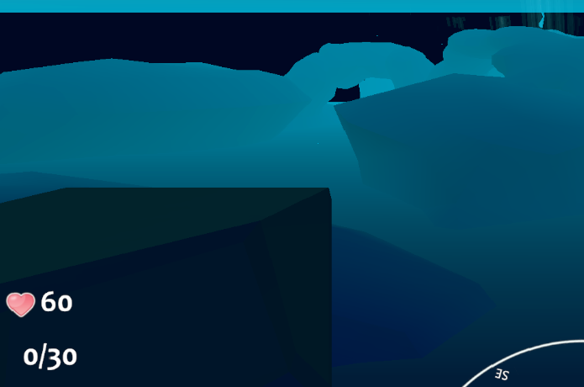

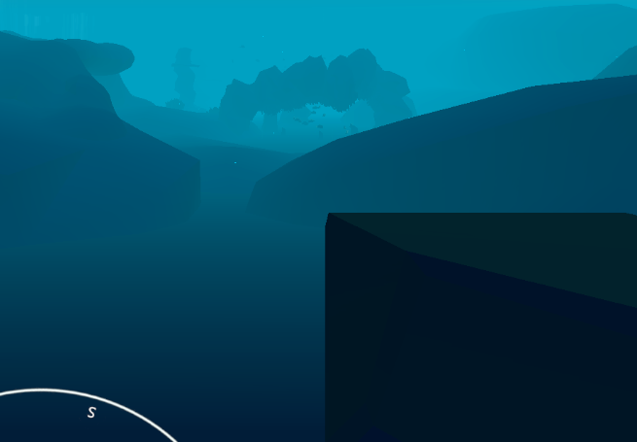

The colour of the background will change accordingly to the fog colour in the current zone, producing the desired effect. The code looks like the following:

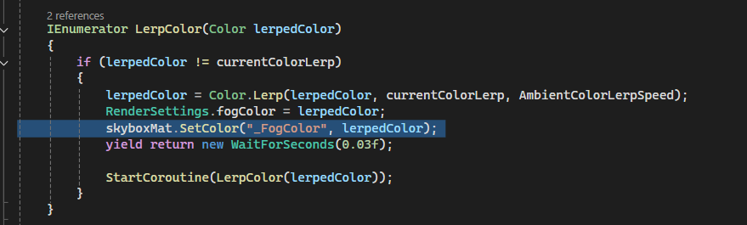

The ShaderGraph corresponding for this behaviour looks like the following:

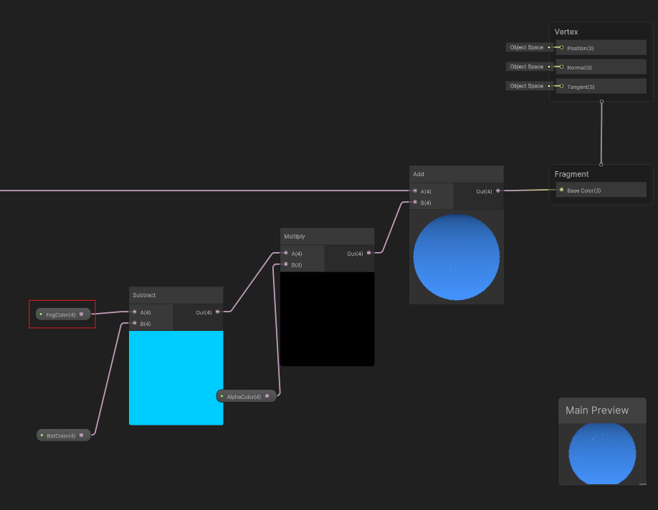

In this same shader, we also have a the creation of the stars in the sky. I is possible to dictate the number of stars and their size. These stars have a noise filter applied which moves through time producing an effect of flashing stars. The rest of the shader looks like the following:

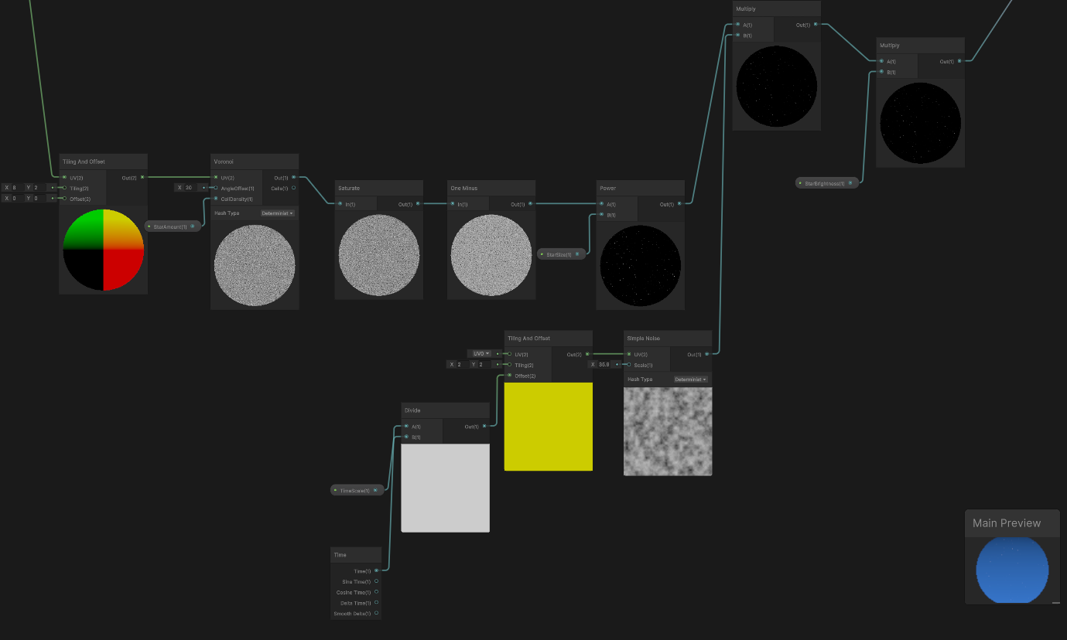

When can play with the values in the shader to produce the desired result:

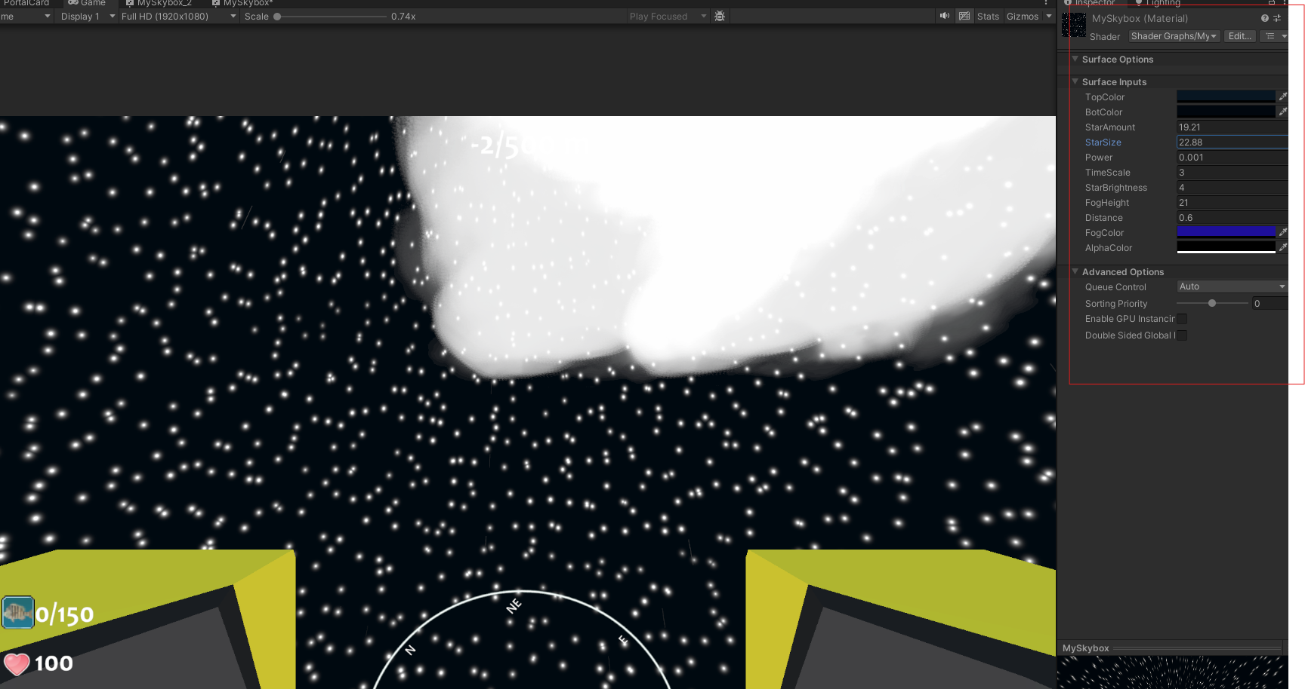

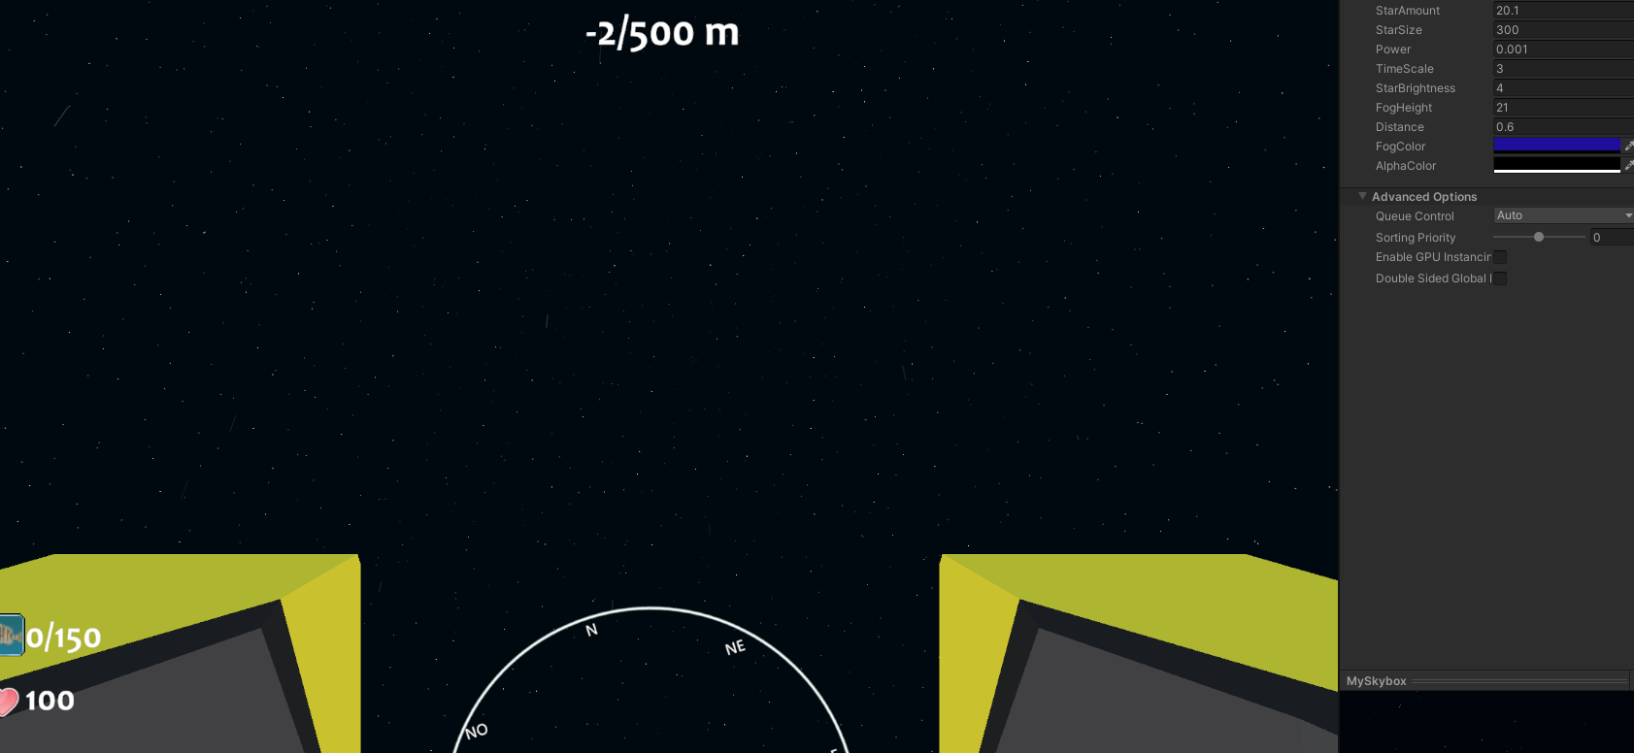



-Game Feedback

Game feedback is very important because it is what it captivates players to play the game. This feedback can be from different sources like ambient, sound and particles. Basically everything that enhances the player experience, so players feel better while playing the game. These enhancements are done by including several small details which as whole, make up a new complete and better experience when playing. The game Mistérios Aquáticos tries to do this by concentrating in the following aspects:

-Ambient

Ambient has to do with how the scene is built and if it is immersive enough for the player. By populating the world with more fish, stones, sea life, we get the feeling that we are underwater.

Another detail that offers some immersiveness to the player is the addition of weather. There are several types of weather that the player can encounter:

Clear sky, clear night, rainy cloudy night, cloudy night, cloudy day. Each day and nighttime have their own different water and ambient colours, offering a better experience to the player.

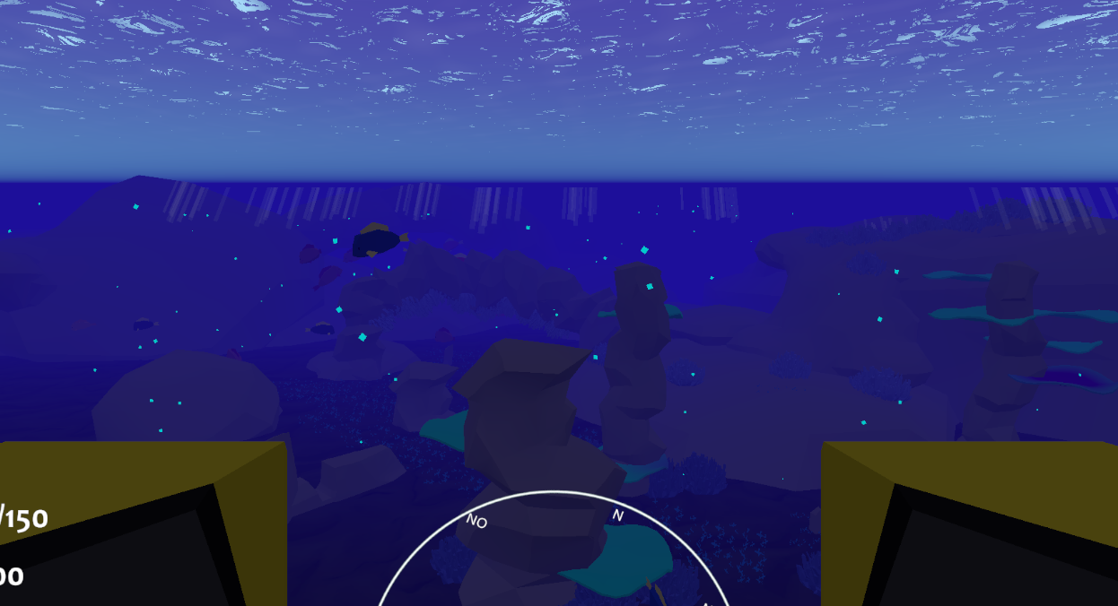

-Sounds

Sounds are another part that contribute to the player immersiveness. Ambient sounds like the ocean waves, or the sound linearity of the seamoth, meaning that the start and stop of the engine are not abrupt, contribute to a real feeling.

-Particles

Particles help us give more feedback to the player. The addition of these contribute to a positive experience to the player. Some examples of these particles are, for example, the water and bubbles appearing when the seamoth rises above water or dives underwater.

-Player engagement

-Tutorial

Since this is not a simple game, a tutorial is needed to inform the player on what he will need to do. It explains the game and gives a tour around the island.

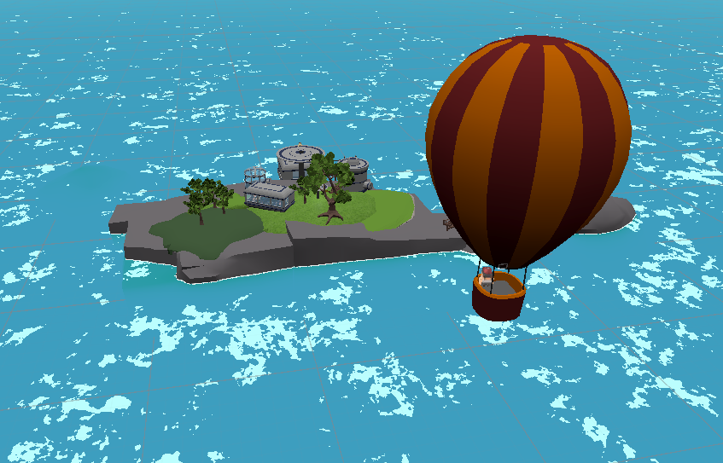

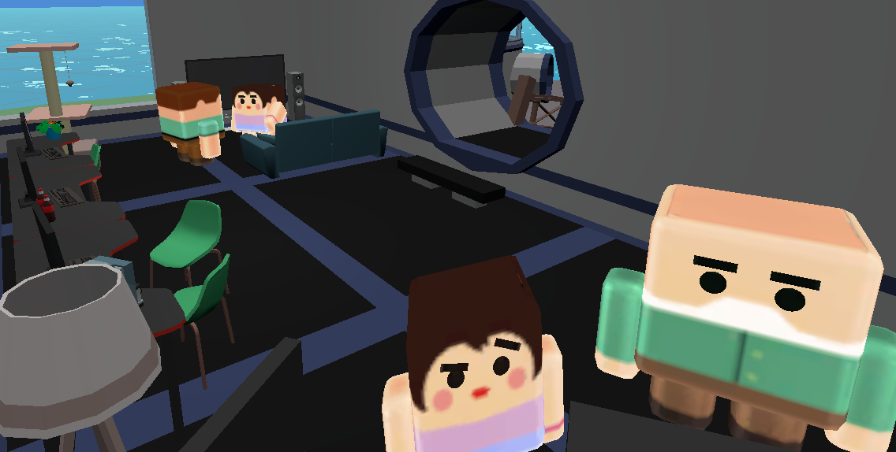

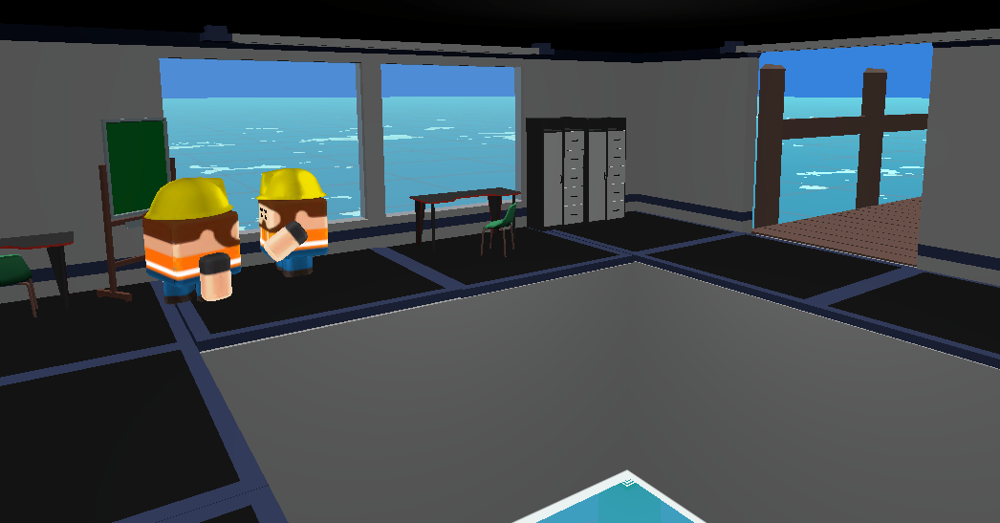

-Zones

Humans are naturally curious, that is why we have come so far. That means that by adding more zones we motivate the exploration, hence our natural behaviour kicks in.

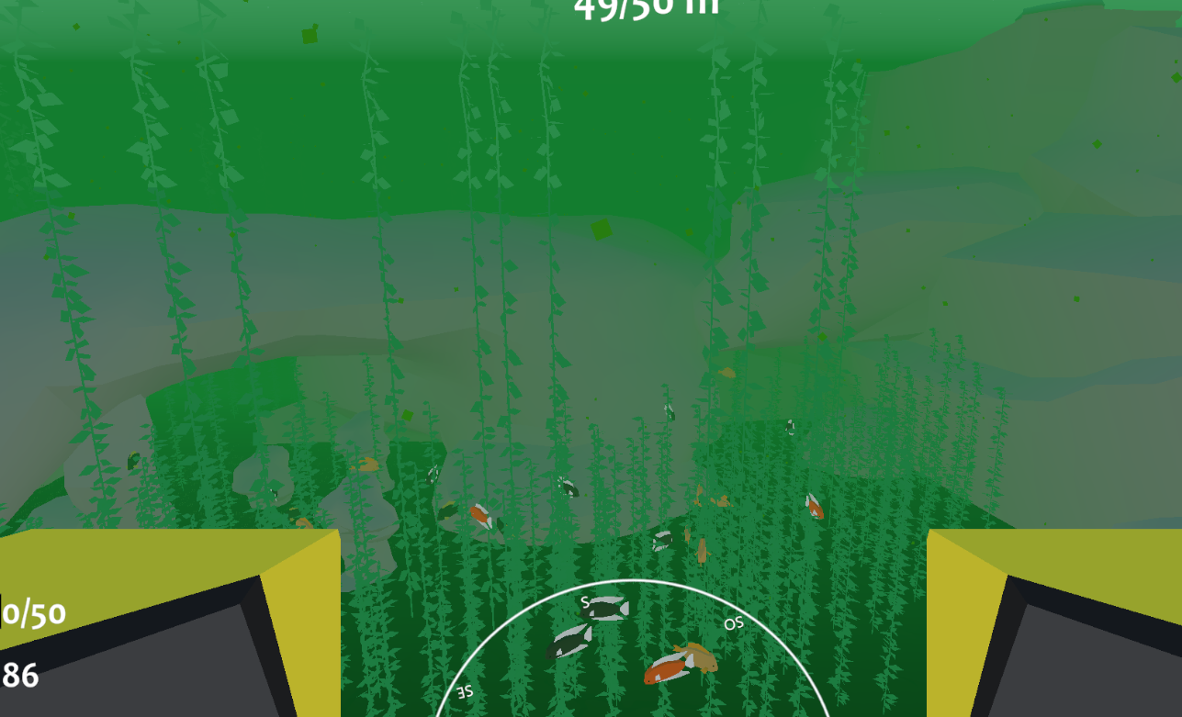

-Achievements

No true game is complete without achievements. Players will complete those when exploring new locations and catching new items.

-Unlockables

All this exploration has to be unlocked. All zones are accessible to the player, however, without the proper modules that can be unlocked, the player will quickly realize that it is in vain to continue exploring further. If so, it will result in a catastrophic failure of the seamoth and needs rescue.

These modules can be unlocked in the store using in game currency, coins. Coins are gained after a day of catching fish. Fish can be stored either in the player inventory or the underwater inventory, where two divers are there at your disposal to store some fish for you. Players can terminate the day at any given time.

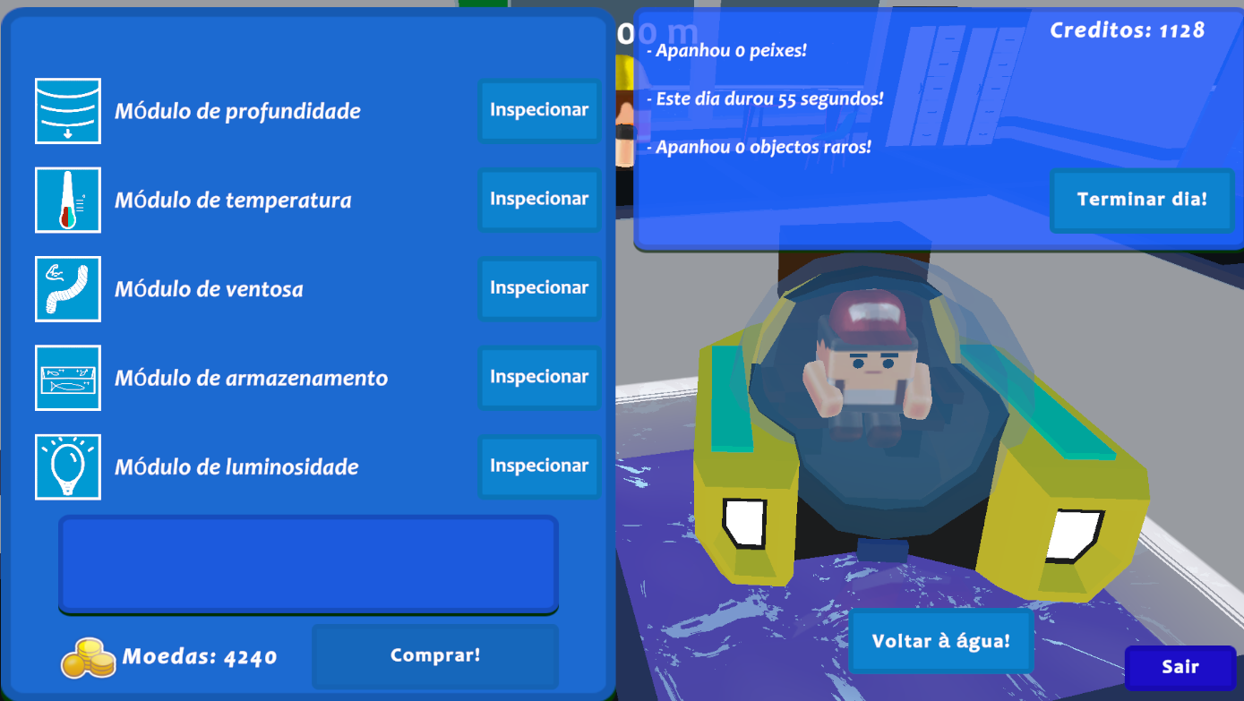

Each upgrade changes the seamoth visually to let the player know that the upgrades are taking place.

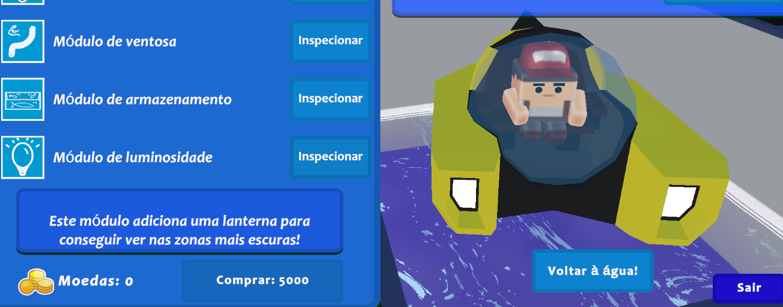

Choosing to buy flashlight

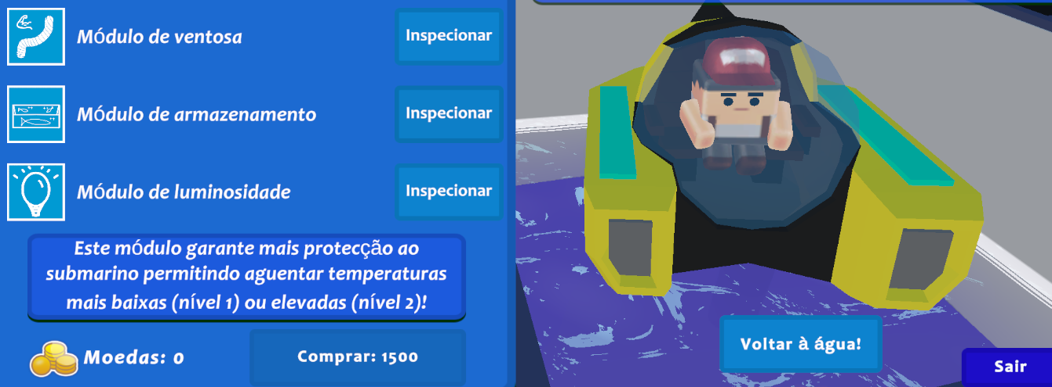

Choosing to buy temperature module

-Saving

Saving is done by terminating a day. Each time the player terminates a day, an update to its state will be called with everything that he has done. This includes credits, coins, fish caught, upgrades on modules, time played, etc.







-Player retainability

-Day streak

It is obvious that real world rewards are also a motivation for the player. So, we have decided to insert a streak bonus, where the player will gain extra credits if it is on a gaming streak.

-Progression

The game already has some complexity to it with several areas and upgrades to buy. This gives a purpose to the player and motivates him to keep playing.

-Scalability

The game was made in a very dynamic way. The code is prepared in a way that adding new fish types and fish spawns is very easy. In the image below we can see the different fish spawn places and their waypoints, highlighted as red line volumes.

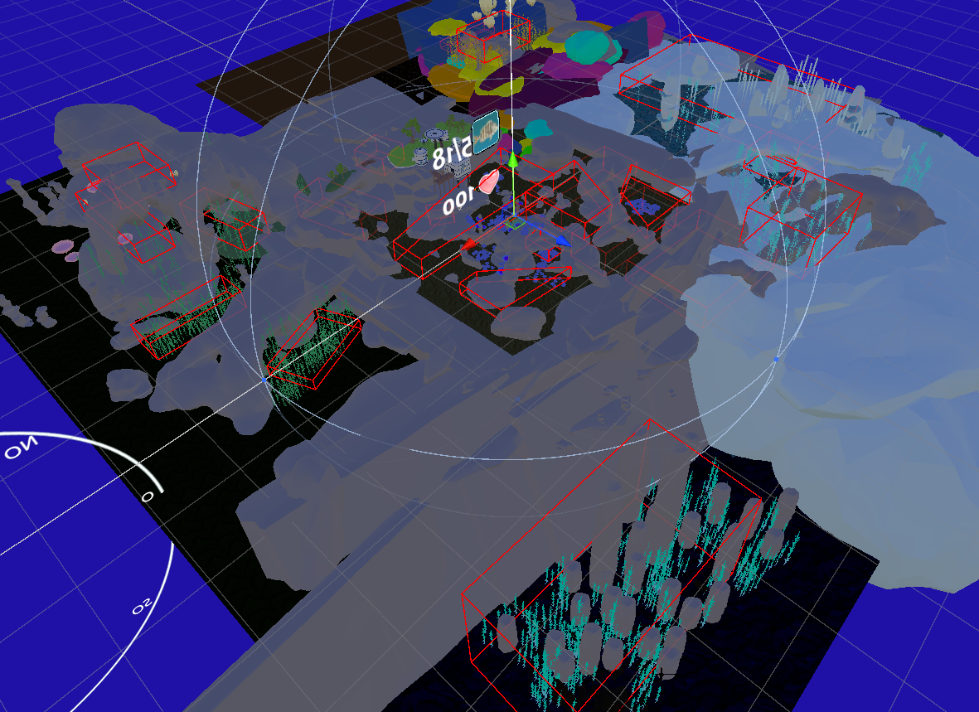

The zones are highlighted as green lines volumes:

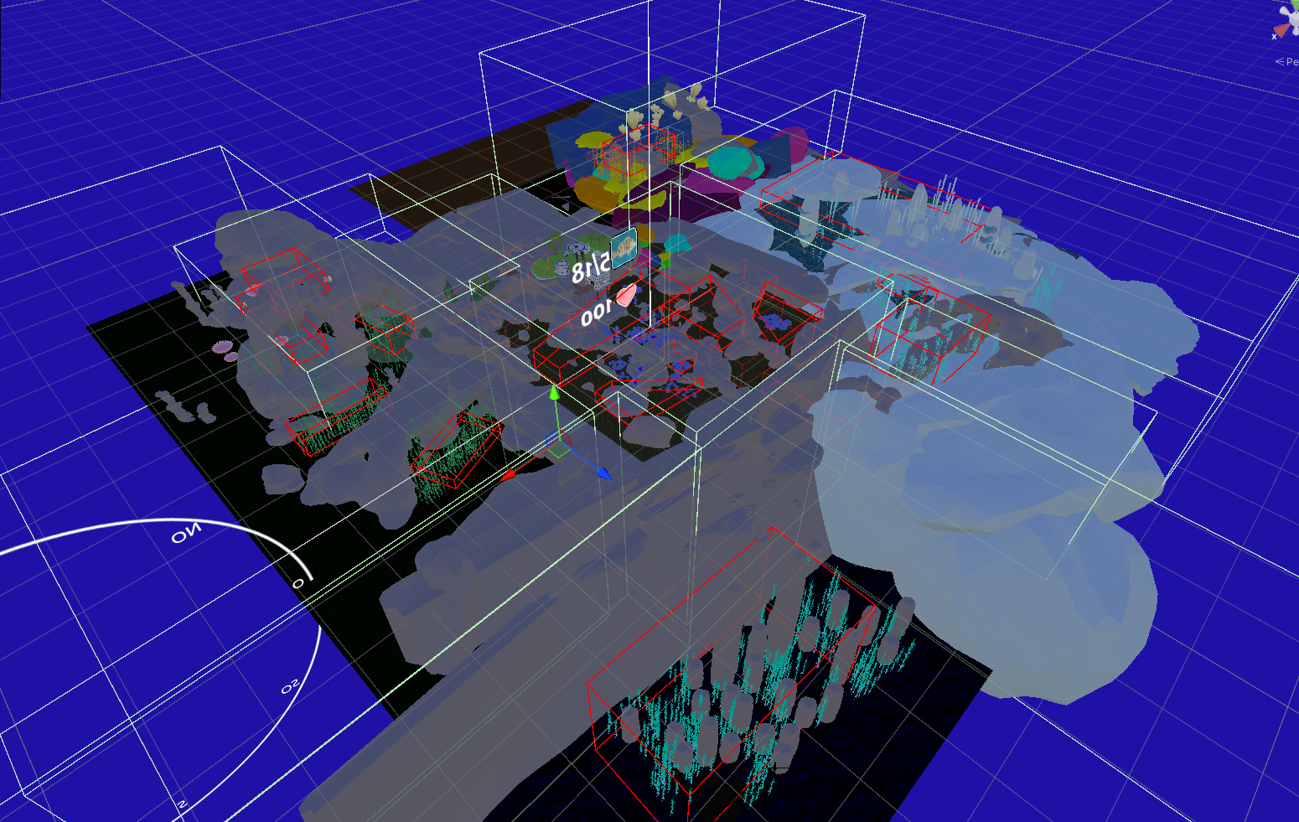

It will be described in the sections below.

-Creating new zones

The process of creating zones was not designed to add new zones in an easy way. However, it is possible to do so. Every zone has a script which dictates which zone it is. Each zone knows the other zones because we deactivate them for performance reasons. We simply create a new collider with the size of the zone we want, add the new zone in the Zones script code and assign its Boolean value.

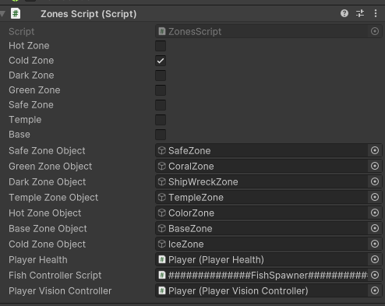

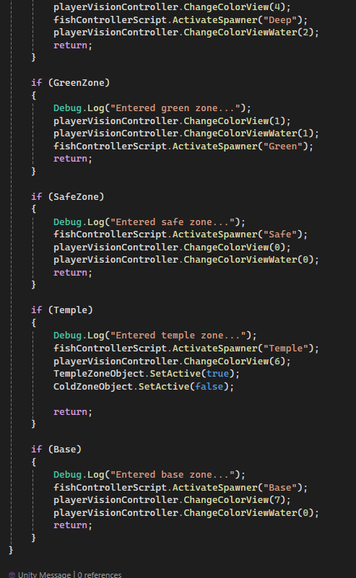

-Creating new fish spawns

Adding new fish spawns is also quick. Each zone has a fish spawner script attached to it.

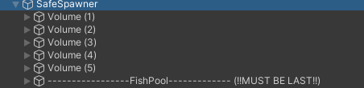

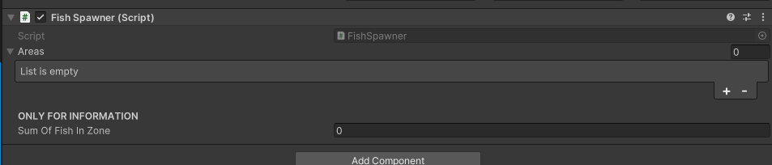

Then we decide how many volumes do we want our zone to have. In this case we have five volumes for the safe zone. Each volume must contain in the first position the spawn points of the fish, followed by eight vertices.

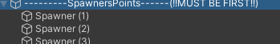

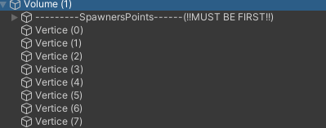

We have gizmos in the code so we can see the vertices better.

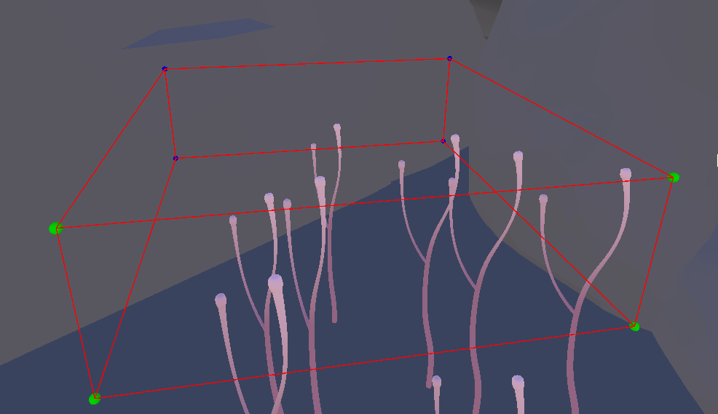

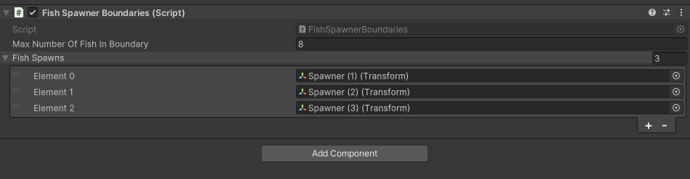

We can pick how many fish we want in the determined volume and

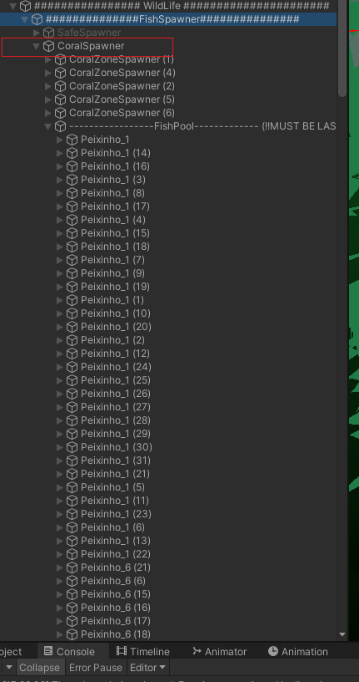

-Adding new fish species

Adding new fish is simpler than adding new zones. Once we have the model we want for the fish, we just need to assign it three components. One collider with the “Is trigger” flag on, a Fish script and a FishWaypoint script. Make a prefab out of it and just add some to the fish pooler of the zone we want them to spawn in. We just need to choose the fish space size and the money worth values. The fish type functions like a fish ID, so we need to make sure that fish type is not taken.

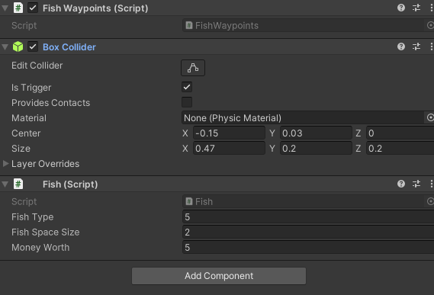

-Fish movement

Fishes are not the smartest in the game. Each fish choses a random point in the volume of his spawn zone and goes there in a straight line. When he reaches its destination, a new waypoint is calculated.

Gameplay

-Receiving data from Proxy

Over the course of the development of the game, the gameplay was made using the usually key bindings.

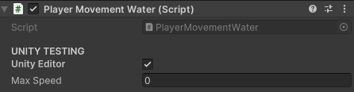

When the Unity Editor is ticked, the movement and camera rotations are the same as other ordinary games. This was made only for development and testing, since the final version is meant to be played purely by movement.

To make this matter possible, we use MediaPipe to capture movements and then map them to gameplay. This mapping is captured by a python program, proxy (client), that is constantly communicating with Unity (server) through socket communication. This communication needs to be fail safe, if not, Unity becomes very slow to the point of being unplayable. We capture the data and send it as a json to Unity:

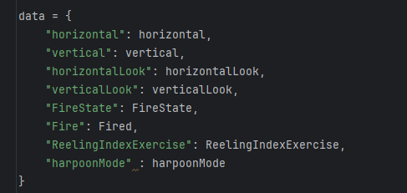

In Unity, we receive this data and decode it to fit our needs. We have the same data that is received from the client.

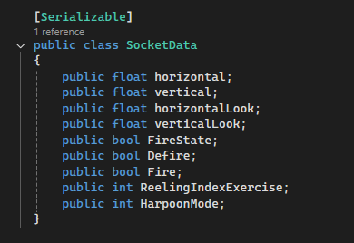

This data is needed to play the game and it is this data that we receive from the client by json. The mapping is done using the following method:

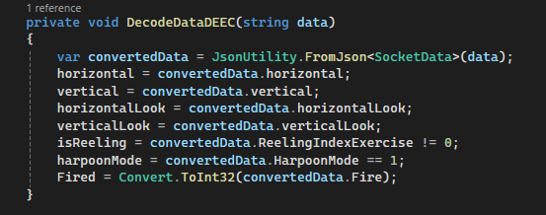

However, the data was being repeated and sometimes split. To fix this issue a method was created:

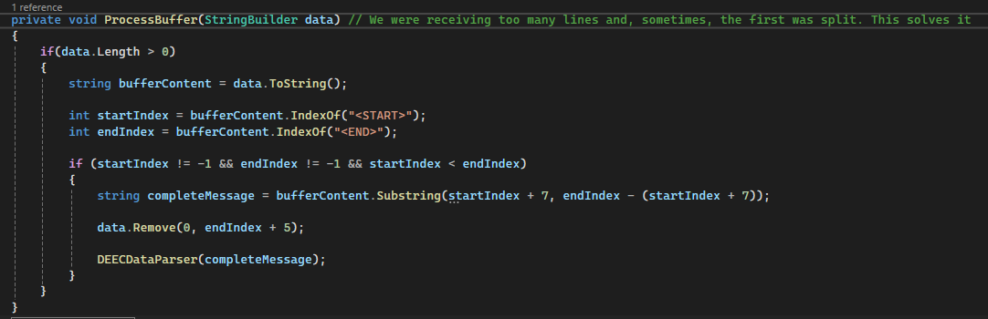

-Mapping data

For the game to be played we need to map the seven variables from player movement in real life to Unity movement. These variables are the ones that are common in normal gaming, which is like Mistérios Aquáticos is using when in development mode. If we look at the development movement, we see that we use the keys WASD to move. These keys control the movement of the player in the XY axis, while the PlayerLook script controls the direction of the movement, which is used with the mouse. This mouse movement is also based on the two axis X and Y, which gives us a direction. So, basically, we have vertical and horizontal movement, much like the WASD keys. And we have a vertical and horizontal look value, mimicking the mouse input. We also have the key Q which makes the player enter the fishing mode, and E returns to normal movement mode. Finally, we have the F key which fires the suction pad to catch the fish and the exercise itself to see if it is reeling the fish. The Q and F can be the same variable since they are two faces of the same coin. Meaning that we can choose movements that can be mapped to these variables.

-Reeling fish

Once we map the accepted exercises to the isReeling variable, we simply turn the variable to true, meaning that is reeling the fish. If the player takes a long time to reel the fish, the fish will break free from the suction pad.

Game credits

-Adjusting values

Adjusting values to what is desired is easy. Every script has only the necessary variables showing to adjust. We do this but taking advantage of the [HideInInspector] tag. This removes the pollution in the inspector of values that we are not interested in changing. Here is an example of the store script in the inspector window:  
  
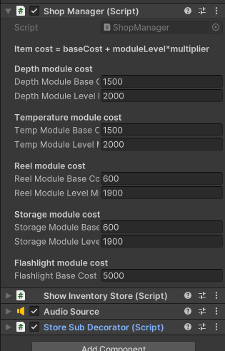

However, in the code we can clearly see that there are a ton of other variables:

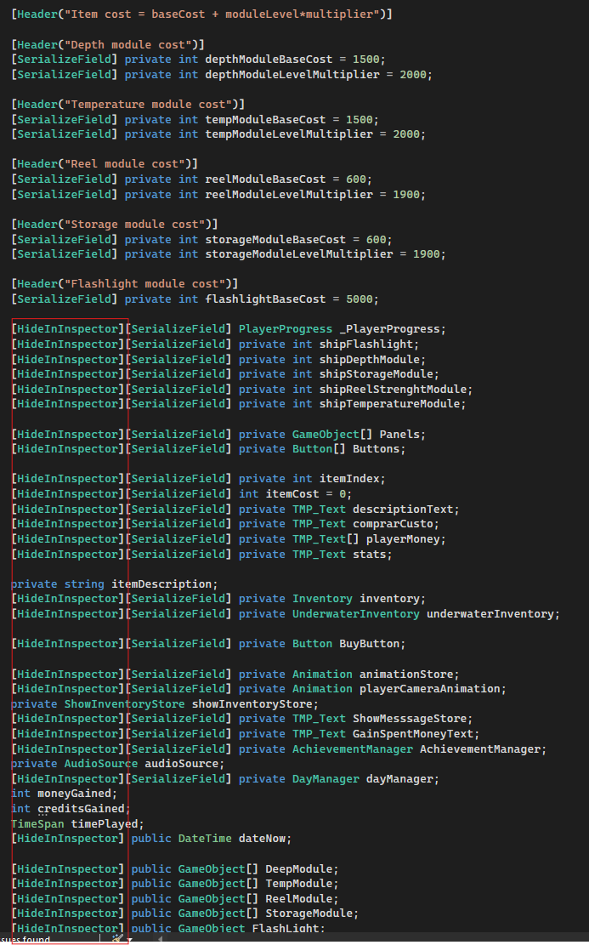

These values control the number of credits a player can win from collecting coins, the amount of credits they win per fish caught and achievement caught. The store prices can also be changed accordingly.

**Web development**

-Technologies used

-Blazor

-Visual studio 2022

-.Net 8

-Frontend

-Web page

The Blazor application is responsible for the frontend, which is where the students will register their student numbers. Students will have a QR code available that redirects them to the correct domain.



The QR code was made by using a free QR code generator.

This application is also running in a docker container in a server. The URL was configured with the ports 8080 with SSL certificate, meaning that we have extra security. A domain was bought for one year (misteriosaquaticos.pt) which maps the server IP to that domain. This mapping is nothing more than the domain pointing to the URL. The frontend code is prepared to be shown in desktop or mobile applications.



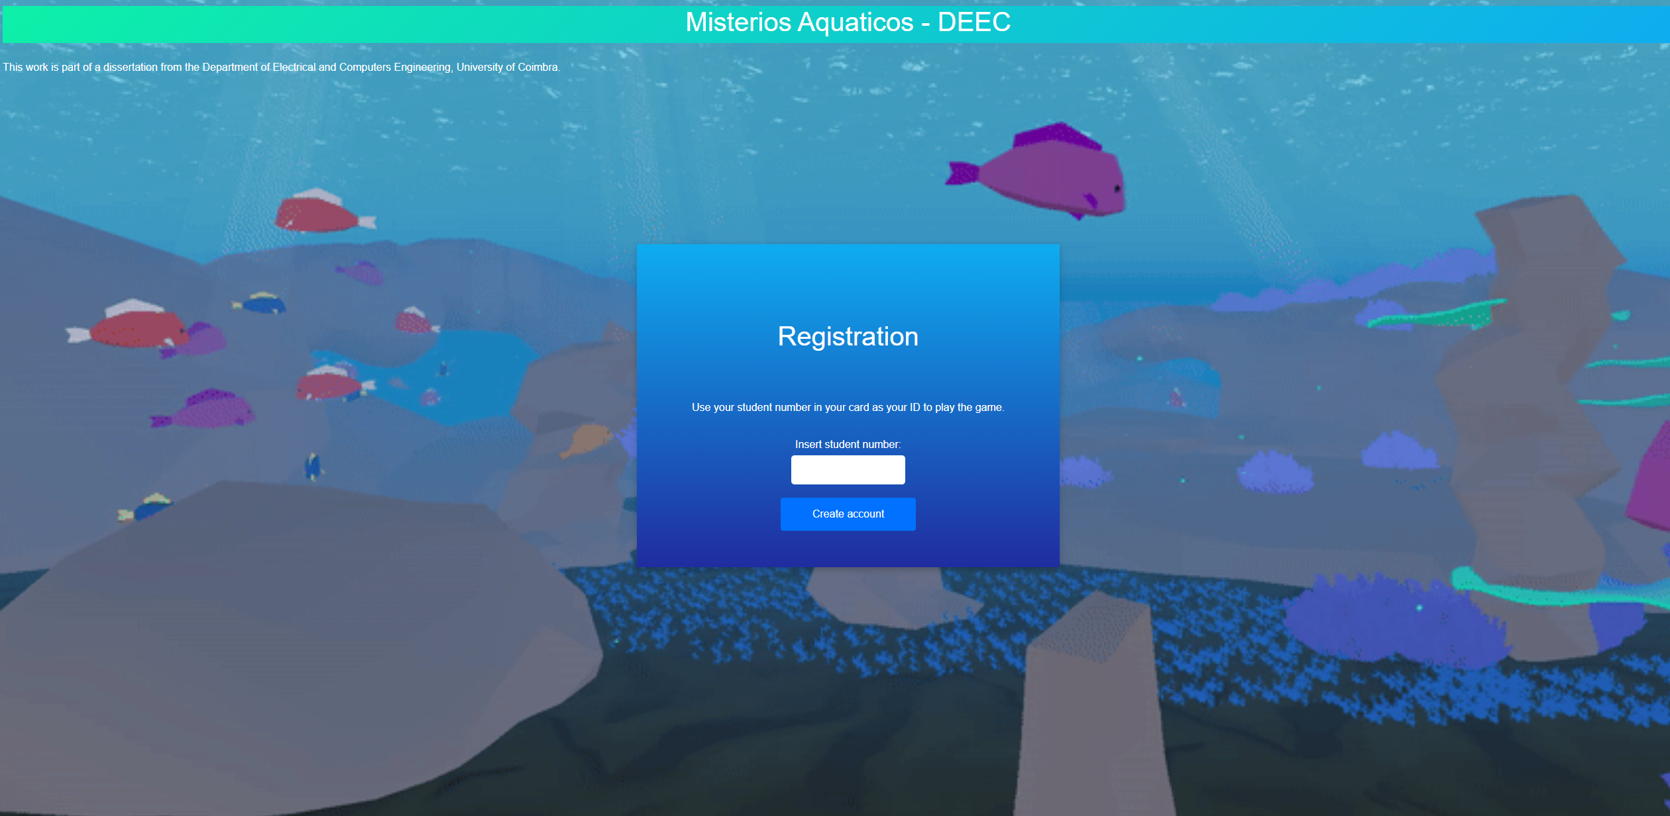

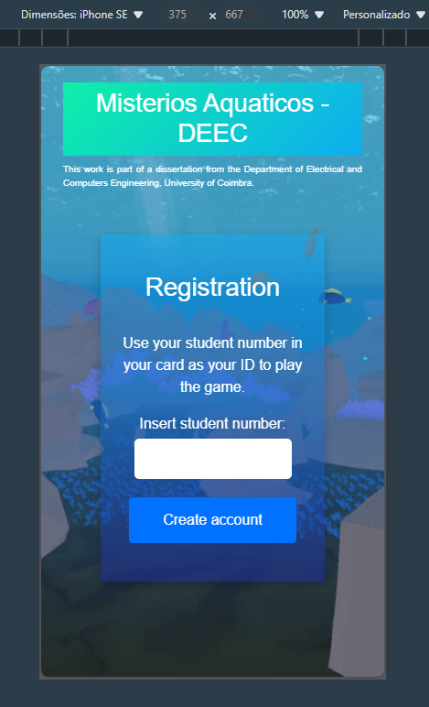

-Port configuration

Since website is what we want to show first, the port it has is the default 8080. This means that the misteriosaquaticos.pt will redirect to the blazor application. However, to communicate with the API, the port 8081 is the one that is being used. This port is being mapped to /api, meaning that any requests made use the following pattern:



-Validations

There are two validations when the user tries to register. There are two validations that ensure the student ID is only composed by numbers and that it has exactly ten digits. There is another validation which ensures that the ID being registered is not being used, however, that validation belongs to the API, which we will cover later.

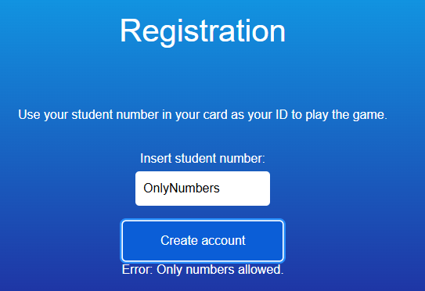

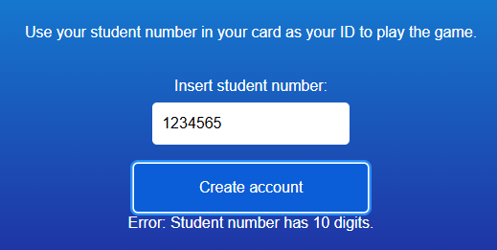

-API connection

The way we are registering players is by calling an endpoint in the API which will validate the ID and check if that ID was already registered. Like mentioned above, the API has its port 8081 open, but it’s mapped thourgh api/. This API was built with .NET 8.

-Backend API

-Endpoints

For our applications to work, we need to do some logic. This logic is done by calling API endpoints. Several endpoints were created to serve our purposes.

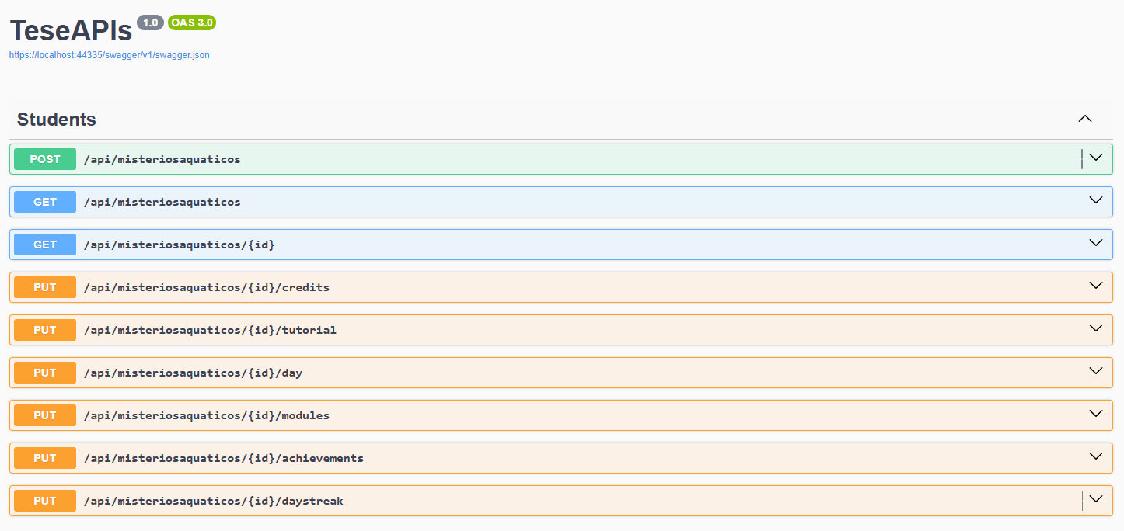

POST api/misteriosaquaticos

This endpoint is called when players are registering. It has a validation that checks if a user with the ID that was sent already exists. Unity and SuperUser application call this endpoint.

GET api/misteriosaquaticos

This endpoint returns all the players and their data that exist in the database.

GET api/misteriosaquaticos/{id}

This endpoint returns one player with the ID sent and his data. SuperUser application call this endpoint.

PUT api/misteriosaquaticos/{id}/credits

This endpoint updates the credits of the player with ID sent. The credit value is sent in the body as json. The application SuperUser calls this endpoint.

PUT api/misteriosaquaticos/{id}/tutorial

This endpoint is called from Unity and updates the tutorial field of the player with the ID that was passed. This tutorial value is set to one and saved in the database, meaning that this player will not need to see the tutorial again.

PUT api/misteriosaquaticos/{id}/day

This endpoint is called from Unity and updates the coins, fish caught, time played, days and credits.

PUT api/misteriosaquaticos/{id}/modules

This endpoint is called from Unity whenever the player buys a new module.

PUT api/misteriosaquaticos/{id}/achievements

This endpoint is called from Unity when the player conquers an achievement.

PUT api/misteriosaquaticos/{id}/daystreak

This endpoint is called from Unity whenever the player enters the game. It calculates the last login and, if fit, it updates the day streak value. This value will affect the number of credits received.

Day streak 0 – x1.0 multiplier;

Day streak 1 – x1.25 multiplier;

Day streak 2 – x1.5 multiplier;

Day streak 3 – x2.0 multiplier;

These values can be adjusted.

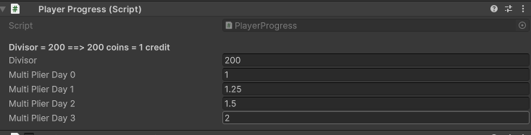

There are times when we need to obtain information, so responses were created.

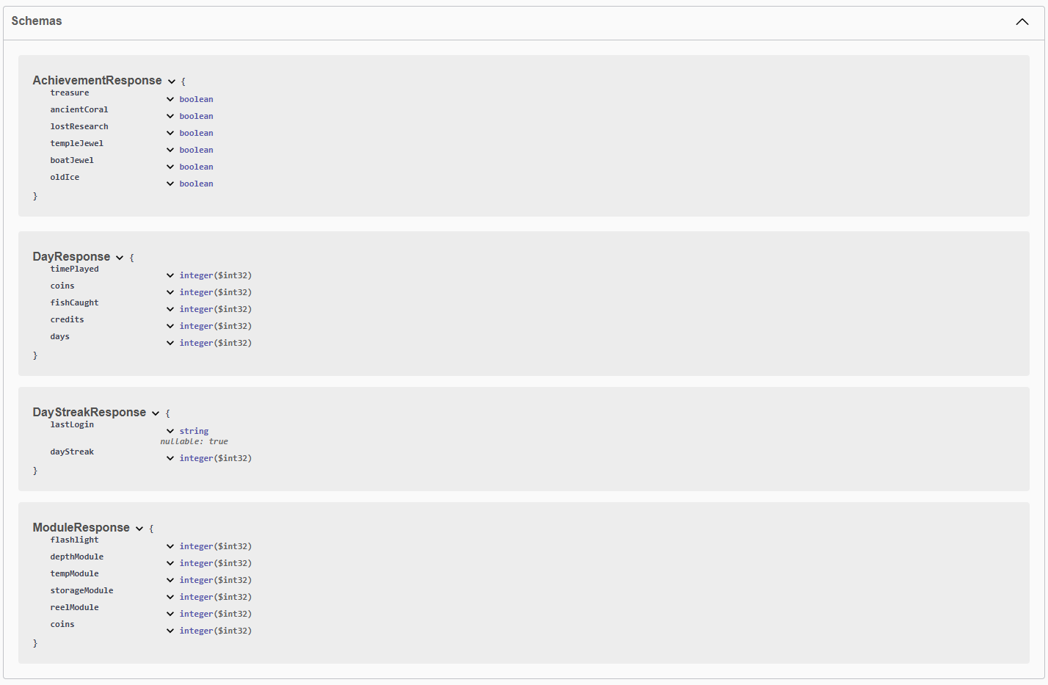

-Swagger

-Postman

Postman is also a great tool for testing our API endpoints.

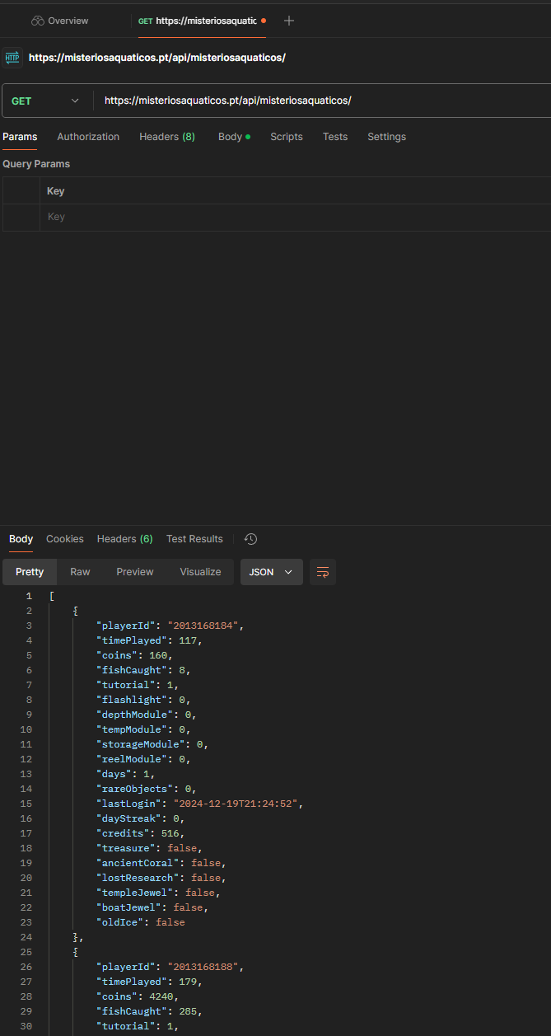

-Port configuration

The port that was configured was the 8081, which we redirect to /api.

-Architecture & good practices

-SOLID principles

SOLID principles are a set of principles on which programmers try to implement it to develop cleaner and more readable code. Each letter in SOLID means one specific tactic.

Single responsibility

Open close principle

Liskov substitution

Interface segregation

Dependency inversion

-REST APIs

Controller logic, Model, Repository.

-Testing the API

Testing is a very important part of software development, and it is commonly used in professional world. The two most important are Unit and Integration tests. There are also end to end (E2E) and contract tests, but these are not part of the work.

Unit tests: Unit tests are created to test the logic and ensure that changes won’t ruin functionality. They are usually small and targeted to small pieces of code.

Integration tests: Integration tests are broader and test more functionality. Any database related functionality needs an integration test.

-Validations

Validations are very important and are a layer of defence for our application. These are usually done so the users do not do anything bad and, if they do, we give a proper message about it.

In the API that was built we have the following validations:

-Check if user is registered.

-Ensure the credits value is higher than 0 when updating credits

-Client Resilience

Client resilience is a good practice to have since the requests can fail sometimes. This implementation means that the request will try a certain number of times before it fails. For this we use the Microsoft http resilience nugget package.

To use Resilience, we first need to inject it in our program.cs class.

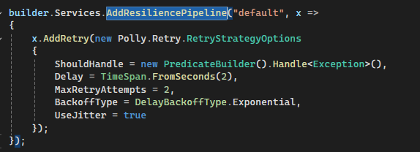

This means that for our default resilience pipeline, we will use the options described above. Using exponential as a back of type is a good practice, and so is using true in use jitter.

And in our API controller we need to add the following code, so we use the pipeline instead of the normal API call.



-Authentication

Authentication is a very important feature to have in the API. If not, anyone could call the API endpoint and update it. With authentication, we ensure that only the one that are authenticated can call these endpoints.

-Database connection

Since we are using Sqlite as the database, the connection is done by changing the DB_PATH to the sqlite .db file. This sqlite file is stored in the Docker container.

-Github

-Source control has an important role keeping up with the changes of a project. It is especially important in the professional world, where several people contribute to parts of a project.

-Server

-Server context

To be able to have our applications running full time and have a way to store player data, we need a server. A simple server is enough for this project. This server is a simple linux machine where Docker was installed and our sqlite file stored.

The host used for this was Hetzener.

-Command line

To connect to the server, we use the command line. By using the command “ssh user@serverIp” we can connect to the server and manage it from here.

-WinSCP

Although everything can be done by command line, WinSCP offers a more intuitive way to manage the server.

-Domain misteriosaquaticos.pt

-Mapping server IP to domain

To be demanding in terms of professionalism, and for security reasons, we should not have our IP as our address. For that we use a domain. The domain misteriosaquaticos.pt was bought and is now mapped to the server IP that was hired.

-Why use domain

Leaving the server IP as the url would not look professional, but also we would be sharing the server IP with the whole world. This could mean that we could be subject to attacks.

-Database

-Why SQLite

SQLite is a fast and lightweight database that does not need an instance. Therefore, it works as a file that we can run sql commands against it.

-Tables schema

We have two tables in this database:

MisteriosAquaticos

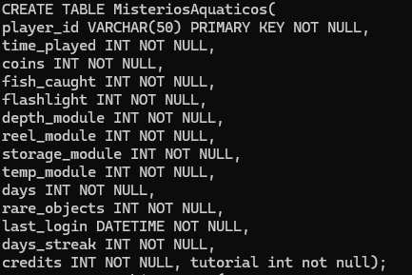

Achievements

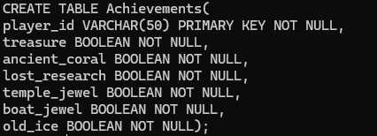

-Docker

-Why use Docker

To be able to have our application running constantly, we need to have it store and running somewhere. This where docker comes in handy. It allows to run images based on the dlls of the project and keep it running.

-Setup in server

The server comes as an empty linux OS. It is needed to the the installs necessary to have the docker running, as well as some other useful commands.

-Docker images

Docker images are built from the dockerfiles. These dockerfiles require the project dlls to be able to build the image. When the images are built, we can build containers.

-Docker container

Docker containers are built from images, and they allow us to have our applications running.

-Fast deployment

-GitActions

GitActions function like azure pipelines. After a commit, a build job starts that startings building the application and afterwards it signals and sends dockerhub the new code deployed. This is done by creating a main.yml file. For this project it was created one job with four steps.

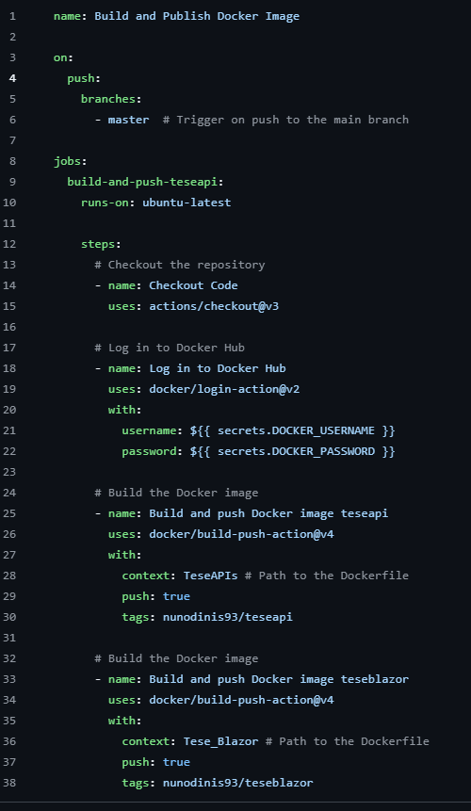

-Dockerhub

Dockerhub receives the necessary to build ´the new images.

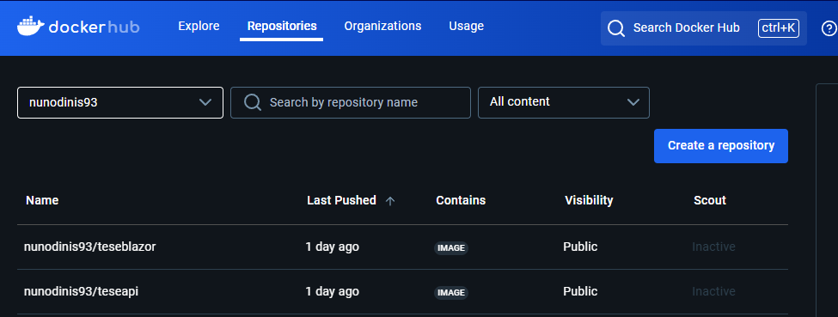

-Watchtower

Watchtower is very handy because it automatically detects and builds new images if new changes are made. It runs a checkup every minute and, when it detects a change, it deletes the containers that is looking at and built new ones with the updated images.

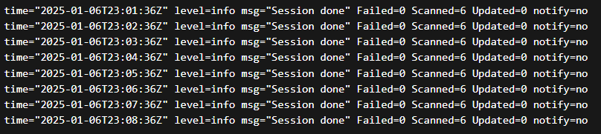

-Nginx SSL certificate

-Why need SSL certificate

SSL certificate allow us to use the https in our website instead of the http. The http is not only not safe, but also not professional.

-Port configuration

-How it all connects

Every time an update is made on the code and sent to Github, GitActions caughts that change, builds and send it to dockerhub. Dockerhub creates a new image based on what was built, sends it to the server and this change is caught by watchtower which will proceed to the deletion of the old container and creation of a new one based on the latest docker image

.

**Proxy program**

-Socket communication

It communicates to localhost. However, we could just change the IP to another machine for it to work.

-MediaPipe

-Mapping movements

**Super user APP**

-MAUI app context

Since there is still no current connection between the academic services database and the one in this project, we must create a way to update the player credits and manage the rewards. Since this is a sensible data, the application SuperUser was built in MAUI. This application runs in a responsible person machine, and it is able to update the credits of the students. It should be that person that, when updating credits, the rewards are given. In the SuperUser application, the user gets a list of all students, or an option to search for an individual student. When clicking on the student number, the data of that student is automatically loaded into the fields “Student ID” and “Credits”. The user can then change the “Update credits” input value and add, or subtract, a certain number of credits.

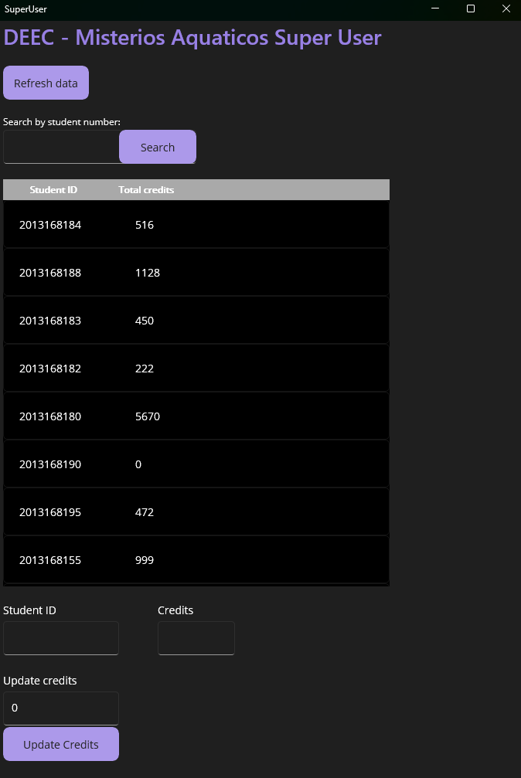

-API connection

The API connection is done in the program.cs file.

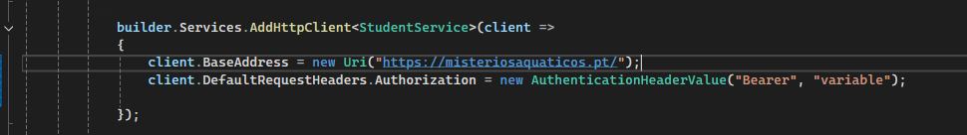

We need to change the BaseAddress of the client with the URL of the API, and in the methods of the API calling, we insert the rest of the URL:  
  
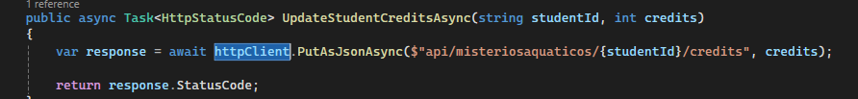

-Receiving students

As mentioned above in the API section, we have endpoints that allow us to get all students. These students will then be added to a list where it will be displayed.

-Updating credits

When we choose a specific student, we can add or subtract credits to that student. This is done by calling the API that manages the update of the credits.

**Rewards**

**-**So far, the rewards must be managed from the SU app, however, it would be a good future work to combine this project with the University.

**Conclusion**

With the game, proxy, API and super user app, we create a working ecosystem which communicates between itself. This not only promotes exercise to students in a fun way, but it can also help anyone who is interested in taking their software to the next level.

**Repository & Source control**

[**NunoDinisSantos/Tese-DEEC**](https://github.com/NunoDinisSantos/Tese-DEEC)

**Scripts documentation**

**Bibliography**